Parallel Middle Body: The length over which the midship section remains unchanged is called the parallel middle body
Entrance and Run: The hull underwater portion forward of the parallel middle body is called “entrance,” whereas the part located aft of the parallel middle body is called “run” (Figure 29).
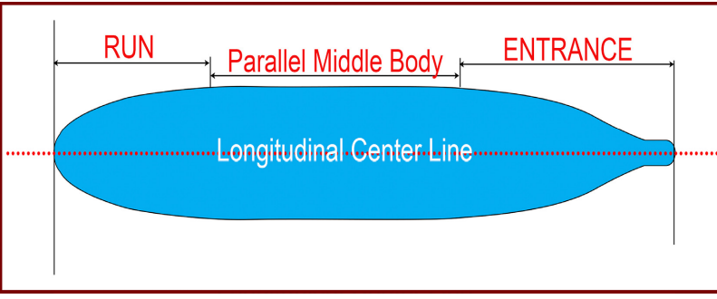
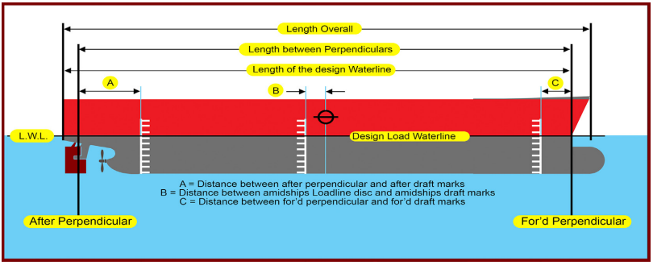
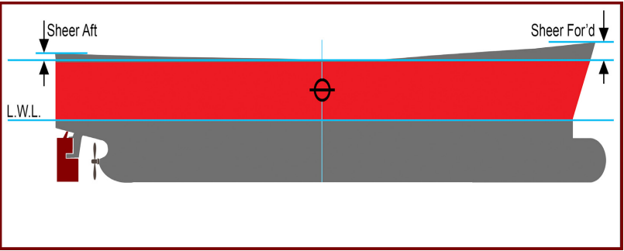
Otro línk en donde está la definición de las dimensiones de las naves bien conciso: https://captaindamley.net/e-modules/general-ship-knowledge/definitions-and-meanings/

Derivadas hidrodinámicas
https://user.engineering.uiowa.edu/~fluids/misc/hsyoon-private_old/Presentation/6.%20Results/PMM/2.%20HydroCoef/HydroDeriv.htm

Estabilidad longitudinal del ship
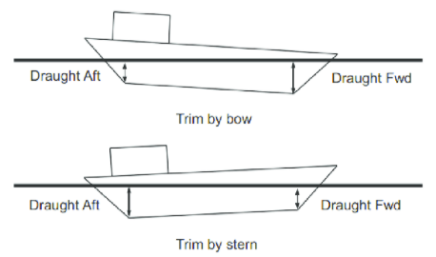
https://www.researchgate.net/figure/Different-Trims-on-an-Arbitrary-Ship-8_fig1_311576476
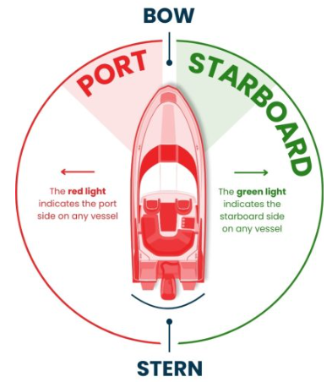
https://driveaboatusa.com/blog/starboard-side-and-port-side-explained/

Establidad transversal
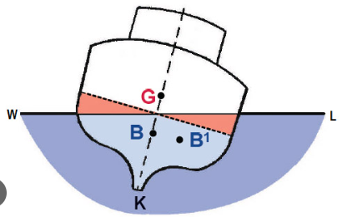
https://plato.is/stability_of_fishing_vessels/transverse_stability/

COSAS QUE VER:
- Hydrodynamical derivatives.
- Postura y ángulos de Euler.
- Efecto Coriolis
https://physics.stackexchange.com/questions/575287/different-coordinate-system-as-opposed-to-different-reference-frame
Explicación de los BODY and inertial marcos de referencia. Euler y demás.

